PROJECT REPORT
FINANCIAL TRANSACTION
& LOAN DASHBOARD
Data Analysis and Visualization Using Microsoft Power BI
Submitted by | S. Thamilarasi
Roll Number | E25FA048
Department | B.Com FinTech with AI
Project Tool | Microsoft Power BI
Week | Week 8 – Dashboard Project

1. Introduction
Banks and FinTech firms record thousands of transactions, accounts and loans every day. On their own, these records are hard to read. A dashboard turns them into a few clear visuals so that a manager can see what is happening in seconds.
This project uses Microsoft Power BI to build the Financial Transaction & Loan Dashboard. It brings customers, accounts, transactions and loans onto one page, with a year slicer (2022–2026) so the user can focus on any period.

1.1 Objectives
- Show the headline numbers (transactions, customers, accounts, loans) as KPI cards.
- Compare account types and transaction types visually.
- Track how transaction activity changes across years and quarters.
- Review the health of the loan portfolio by status.
- Give simple, evidence-based observations and recommendations.

1.2 Tools Used
Tool / Feature | Purpose
Microsoft Power BI Desktop | Data model, measures and report page
KPI / Card visuals | Headline figures
Bar, Line and Donut charts | Category, trend and share comparison
Table visual | Exact transaction values by type
Year slicer | Interactive filtering from 2022 to 2026

2. Dashboard Overview
The figure below is the final dashboard page as built in Power BI.
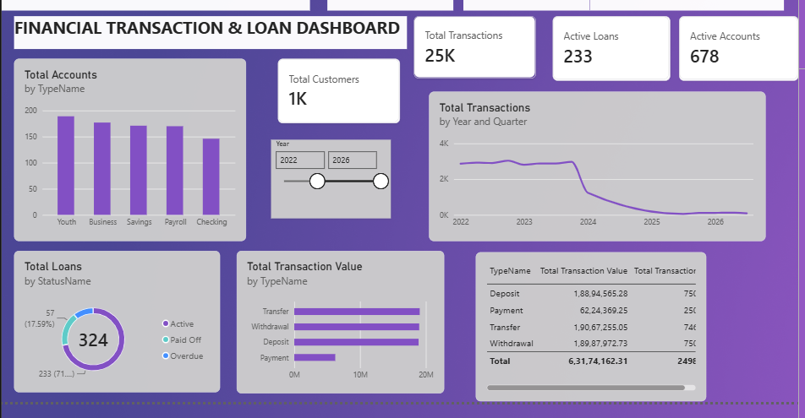
Figure 1: Financial Transaction & Loan Dashboard (Power BI)

2.1 Key Performance Indicators
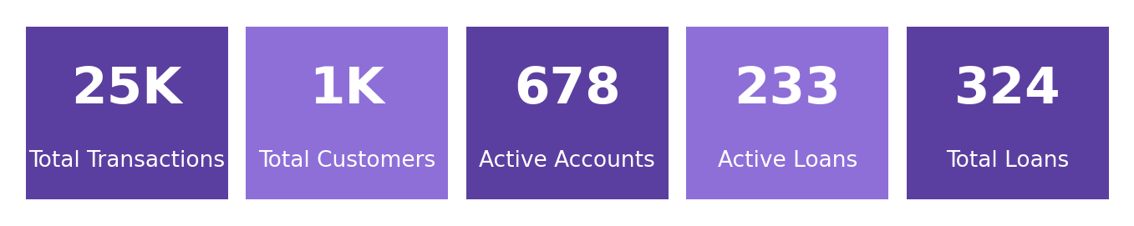
Figure 2: KPI summary of the dashboard
KPI | Value | What it tells us
Total Transactions | 25K | Overall volume of recorded activity
Total Customers | 1K | Size of the customer base
Active Accounts | 678 | Accounts currently in use
Active Loans | 233 | Loans still being repaid
Total Loans | 324 | All loans across all statuses

3. Visual Analysis

3.1 Accounts by Type
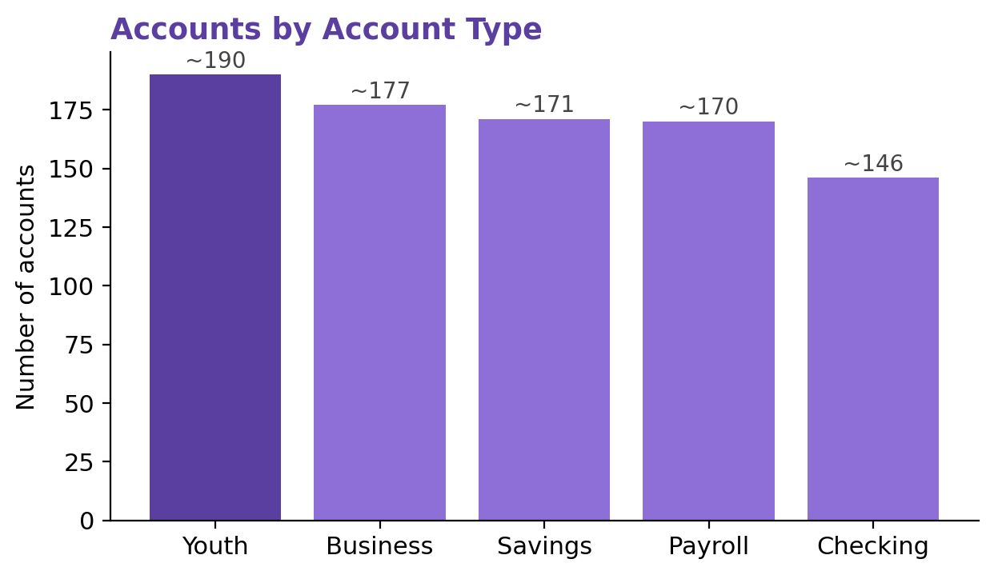
Figure 3: Accounts by account type (values read from the chart, approximate)
Youth accounts are the largest group, followed by Business, Savings and Payroll, which are close to each other. Checking accounts are the smallest group. The spread is fairly even, so the bank does not depend on a single account type.

3.2 Loans by Status
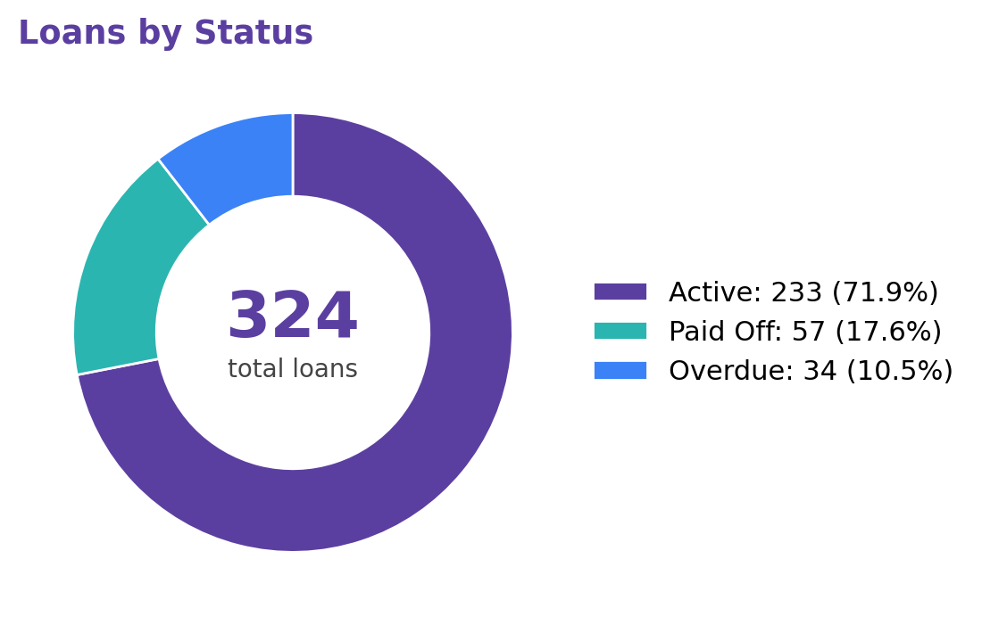
Figure 4: Loan portfolio by status
Of 324 loans, 233 (71.9%) are active, 57 (17.6%) are paid off and about 34 (10.5%) are overdue. The overdue figure is derived as 324 − 233 − 57. Roughly one loan in ten is overdue, which is the main risk indicator on the dashboard.

3.3 Transaction Value by Type
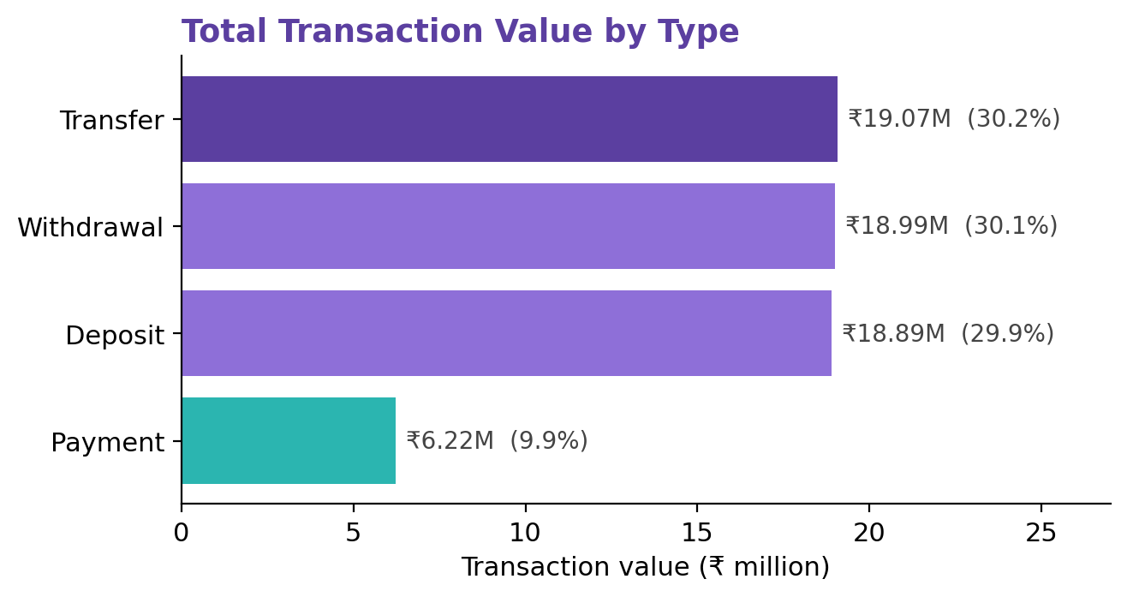
Figure 5: Total transaction value by transaction type
Transaction Type | Total Value (₹) | Share of Total
Transfer | 1,90,67,255.05 | 30.2%
Withdrawal | 1,89,87,972.73 | 30.1%
Deposit | 1,88,94,565.28 | 29.9%
Payment | 62,24,369.25 | 9.9%
Total | 6,31,74,162.31 | 100%

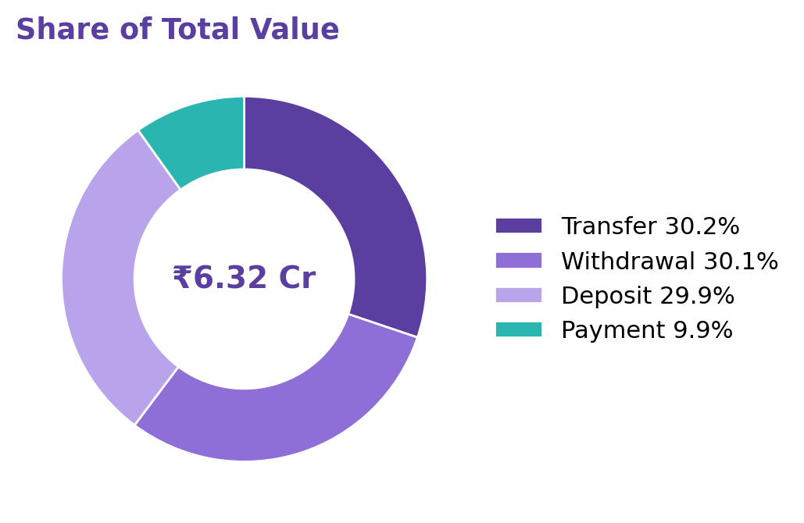
Figure 6: Share of total transaction value
Transfers, withdrawals and deposits each carry about 30% of the total value (around ₹1.9 crore each). Payments are much smaller at about 10% (₹62.2 lakh). With about 25K transactions worth ₹6.32 crore, the average transaction is roughly ₹2,500.

3.4 Transactions over Time
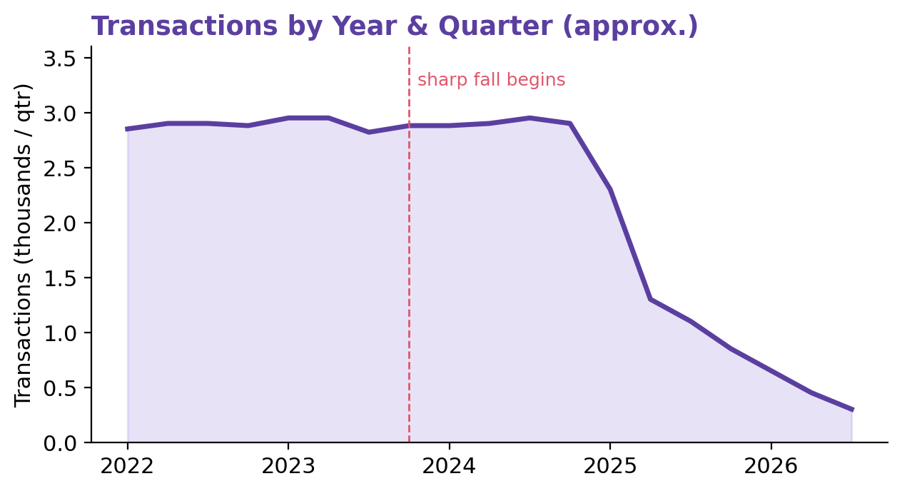
Figure 7: Quarterly transactions, 2022–2026 (approximate, traced from the dashboard line chart)
Activity stays steady at about 3K transactions per quarter from 2022 to late 2023. It then falls sharply, reaching about 1.3K at the start of 2024 and close to zero by mid-2025, where it stays through 2026.

4. Key Findings
- The data covers about 25K transactions worth ₹6.32 crore, from 1K customers.
- Transfers, withdrawals and deposits are equal in value; payments are the smallest category.
- Account types are evenly spread, with Youth accounts slightly ahead.
- About 72% of loans are active and about 10% are overdue.
- Transaction volume drops steeply after late 2023.

5. Recommendations
- Monitor overdue loans closely and set reminders or follow-up steps for them.
- Check why the transaction volume falls after 2023 before drawing business conclusions.
- Promote digital payments, since payments are the smallest share of value.
- Keep growing Youth accounts and look for ways to move Checking accounts up.

6. Limitations
- The dashboard shows what happened, not why; it cannot prove causes or detect fraud.
- The sharp fall after 2023 may reflect how the dataset was built rather than real customer behaviour.
- Account counts and the trend line in this report are read from the chart, so they are approximate.
- There is no loan-amount, interest or customer-segment detail in this view.

7. Future Enhancements
- Add loan amount and repayment measures, and a loan-by-account-type view.
- Add a customer segment filter and drill-through to individual customers.
- Add year-on-year growth measures and forecasting.

8. Conclusion
The Financial Transaction & Loan Dashboard gives a quick and clear picture of transactions, accounts and loans in a single Power BI page. It shows a balanced account base, an even spread of value across the main transaction types, and a loan portfolio that is mostly healthy but has an overdue group worth watching. The unusual drop in transactions after 2023 is the most important point for further checking. The project shows how business intelligence can turn raw financial data into simple, useful decisions.
S. Thamilarasi | E25FA048 | B.Com FinTech with AI

